Hospital management

# A Project Report on

##### 2021-2022

Hospital management

Geetanjali College, Rajkot

**Hospital management system Developed by**

**Pratik Gosai**

#### Guide by Prof.MalayDave

###### Submitted in partial fulfillment of the requirement

**For the award of the degree of Master of Computer Applications (MSC I.T&C.A)**

**Year of Submission 2022-2023**

**Saurashtra University-Rajkot**

Hospital management **2021-2022**

# Preface

The main objective of any computer science student is to get practical knowledge as possible. Being able to have a practical knowledge by developing a project is a lifetime experience. As practical knowledge is important as theoretical knowledge i am thankful of having a project.

Through the development of the project i had a great experience of various strategies that can be applied in development of the project. This project is the stepping stone for our career.

i am pleased to present this project report. Proper case has been taken while organizing the report so that it is easy to comprehend. Also, various software engineering concepts have been implemented.

Hospital management **2021-2022**

# Acknowledgement

i am student of M.S.C I.T&C.A Studying in the GEETANJALI College, RAJKOT. i Thanks to the entire person who has given their support in shaping of the system.

i thank Prof MALAY DAVE for giving us guidance and Co- operation in understanding the system. i also thank them for their unconditional help in making of this project.

i have great deal of gratitude towards our head of department who encourage us in taking up this activity. i thank all faculties and administrative staffs of the institute.

Thanks to all!!

**Pratik Gosai**

Hospital management **2021-2022**

## Index

|  |  |  |
| --- | --- | --- |
| **No** | **Title** | **Page no** |
| 1 | **Introduction** | 5 |
| 2 | **TimeLine Chart** | 6 |
| 3 | **Project Profile** | 7 |
| 4 | **Hardware Requirement** | 8 |
| 5 | **Software Requirement** | 8 |
| 6 | **Requirement Specification** | 9 |
| 7 | **Problem Definition** | 9 |
| 8 | **Project Planning & Scheduling** | 10 |
| 9 | **System Analysis** | 11 |
| 10 | **Project Page Structure** | 14 |
| 11 | **Data Dictionary** | 15 |
| 11 | **Data Flow Diagram** | 19 |
| 12 | **ER – Diagram** | 22 |
| 13 | **Use case Diagram** | 23 |
| 14 | **Activity Diagram** | 24 |
| 15 | **Screen Shot** |  |
| 16 | **Bibliography** |  |

Hospital management **2021-2022**

# Introduction

This is a hospital management user interface for managing, monitoring and controlling the system in a Hospital. This application is developed in java, which mainly focuses on basic operations in a hospital like adding new patient information, and updating new information, assigning the doctor for patient. It features a familiar and well thought-out, an attractive online user interface, combined with strong searching Insertion and reporting capabilities. The Backend of the project is designed with Java, MySQL for database connectivity and front end using HTML, CSS, and Bootstrap.

Hospital management

# Project Profile

##### 2021-2022

* Project Name : Hospital Management System
* Developed by : Pratik Gosai

Front End tool : HTML, JavaScript, CSS

* Back End tool : JSP, MySQL
* Operating System: Microsoft Windows 8 &Microsoft Window 7
* Computer System: I3 or Higher, RAM: 4 GB
* Project Details : This system manage all the users

Request, Response like add doctor, User data and also doctor can also view

Appointments. Admin can view all data.

* Completion Time: 3 Months
* Guide by : Prof Malay Dave
* Submitted TO : Saurashtra University, Rajkot

Hospital management

# Hardware Requirement

##### 2021-2022

* 4 GB of RAM
* Multimedia Keyboard And Mouse
* 1.0+ GHz Processor
* Monitor
* 32X CD Drive

# Software Requirement

* Operating System : Microsoft Windows 8 &Windows 7
* Front End Tools : Html, Sublime, css

JavaScript, Ajax

* Back End Tools : JSP, MySQL
* Documentation Tools : Microsoft Word 2010
* Browser specification : Mozilla Firefox

Hospital management

# Requirement Specifications

##### 2021-2022

* + MySQL RDBMS used to maintain the all concerned data.
  + Uses special views to display data
  + Display all types of data using classified reports with combinations of multiple tables.
  + Easily track attendance information of students.
  + Quickly produce attendance bulletin.

# Problem Definition

* + Maintain Users Request
  + Maintain Users Response
  + Maintain Users Scraps (Message)
  + Maintain Users Privacy Settings
  + Users List
  + doctors List
  + Maintain Appointments
  + Maintain Report
  + Appointment List

Hospital management **2021-2022**

# Project Planning & Scheduling

“Hospital management system” is app developed for managing appointment of users. User can create id & password for logging into system. Doctors can view all appointments. Admin can also view all the data of user and doctors. Admin can delete user and doctors. This app helps user to schedule their appointments.

It is having mainly two modules. One is at Administration Level and other one is of user I.e. of patients and doctors. The Application maintains authentication in order to access the application. Administrator task includes managing doctors information, patient’s information. To achieve this aim a database was designed one for the patient and other for the doctors which the admin can access. The complaints which are given by user will be referred by authorities. The Patient modules include checking appointments, prescription. User can also pay doctor’s Fee online.

Hospital management

**System Analysis**

##### 2021-2022

System analysis is the process of identification of objectives and requirements, evaluation of alternative solutions and recommendation for a more feasible solution. In other words, system analysis is the step by step process of gathering, recording and interpreting facts. The main aim of analysis is to determine problem areas and to take solutions to reduce or eliminate them.

* System analysis itself breaks into two stages:

###### Preliminary analysis

1. **Detailed analysis**

During analysis, data are collected from the available files, decision points and transactions of the systems using various tools like Data Flow Diagram (DFD).

Hospital management

**Feasibility Study**

##### 2021-2022

Purposed of feasibility study is to check out the possibility of a computerized solution to the organization’s observed problem before very much money that has been spent on.

A feasibility study is carried out to select the best system that meets performance requirements. Only by spending the time to evaluate the feasibility do I reduce the chances for extreme embarrassment at later stage of the system project.

For the complete feasibility study I need to concentrate on following

Area:

They are of three types:

1. Technical
2. Operational
3. Economical

Hospital management

### Technical

##### 2021-2022

Technical feasibility considers whether the desired project can be completed within the framework of available technology. As our project was website designing, this was not much of a problem, as many advanced web-editing tools are available.

### Operational

Operational feasibility was done to assure that the product that would be developed would be used. Since a cards and gifts has to have a website of its own sooner or later, that wasn’t much of a problem.

### Economical

Our Commercial Website is Economically Feasible Because. We have developed this website only for one time. Only future enhancement is required on the other hand every client can view our site any time or many time as per their requirement. So the future economical expenses are null. So we can say that this website is totally economically feasible.

Hospital management

# Project Page Structure

**2021-2022**

* **User Side**



User Side

HospitalManagement

Login

Home

View All Doctors

View Doctor

Update User Appointment

Logout

* **Admin Side**

Hospital Management

Admin Side

Login Create Users



Delete User& Doctor

View Users

View Doctors

View appointment

Logout

Hospital management

**Data Dictionary**

##### 2021-2022

The data Dictionary is a set of table. MySQL uses it to maintain information about his own database.

###### Data dictionary contains the following information:

* + - Name of the table of database.
    - User information such as privileges.
    - Name and data-type of all columns in database table.

**Database Name**: hospital_database.sql

###### Admininfo

* + This table is used to store admin information.

|  |  |  |  |
| --- | --- | --- | --- |
| **Field** | **Type** | **Null** | **Key** |
| **Username** | varchar(20) | No | Primary |
| **Password** | varchar(20) | No |  |
| **Email** | varchar(30) | No | Unique |
| **Fname** | Varchar(20) | No |  |

###### Appointments

* + This table is used to store Appointments information.

|  |  |  |  |
| --- | --- | --- | --- |
| **Field** | **Type** | **Null** | **Key** |
| **Id** | Int | No | Primary |
| **Course** | varchar(20) | No |  |
| **Status** | varchar(30) | No | Unique |
| **Date** | date | No |  |

Hospital management **2021-2022**

###### Doctor

* + This table is used to store Doctor Information.

|  |  |  |  |
| --- | --- | --- | --- |
| **Field** | **Type** | **Null** | **Key** |
| **dc_id** | Int | No | Primary |
| **dc_name** | varchar(20) | No |  |
| **dc_dept** | varchar(30) | No | Unique |
| **dc_email** | Varchar(30) | No |  |
| **dc_course** | Varchar(20) | No |  |

###### Reports

* + This table is used to store reports information.

|  |  |  |  |
| --- | --- | --- | --- |
| **Field** | **Type** | **Null** | **Key** |
| **Us_id** | int | No | Primary |
| **Course** | varchar(20) | No |  |
| **Us_status** | varchar(30) | No | Unique |
| **St_id** | int | No | Foreign key |
| **St_dept** | Varchar(20) | No |  |
| **St_batch** | Varchar(30) | No |  |

###### Users

* + This table is used to store users information.

|  |  |  |  |
| --- | --- | --- | --- |
| **Field** | **Type** | **Null** | **Key** |
| **Us_id** | int | No | Primary |
| **Us_name** | varchar(20) | No |  |
| **Us_dept** | varchar(30) | No | Unique |
| **St_batch** | Varchar(20) | No |  |
| **Email** | Varchar(20) | No |  |

Hospital management **2021-2022**

**Data Flow Diagram**

The DFD gives brief idea on how the designed system is working. It also suggests to us the type of users who using this system and the process involved in the system.

Represent Data Flow Represent a Form

Represent a Data Table

Represent a Report

Represent a Decision

Represent a Processing

Hospital management **2021-2022**

#### Context level Diagram



Response

Doctors

Login

Login

Response

**0.0**

**Online Hospital Management**

Admin

Login

Response

Users

Hospital management **2021-2022**

#### Admin Side

**1st level Diagram**

**ER - Diagram**

**Sub-admin Side**



**Admin**

Login

Create User

Add

Users/ Doctors

View Users

View Doctors

Logout

Hospital management **2021-2022**

#### Sub-admin Side

**Doctors**

Login

Home

Users

Admin

Appointments

Report

Logout

Hospital management

#### Client Side

##### 2021-2022



**ER-Diagram**



**User**

Login

Users

Appointment

Section

My Account

Logout

Hospital management

# ER Diagram



##### 2021-2022

stat_id

Username

Password

Course

**admininfo**

**Appointments**

Email

Fname

st_status

Phone

stat_date

Type

Dc_nam

Dc_id

Dc_dept

**Doctor**

Dc_emai

Dc_cours

us_id

us_id

us_name

Course

us_dept

us_statu

**Users**

**Reports**

st_name

st_dept

st_batch

st_email

st_batch

Hospital management

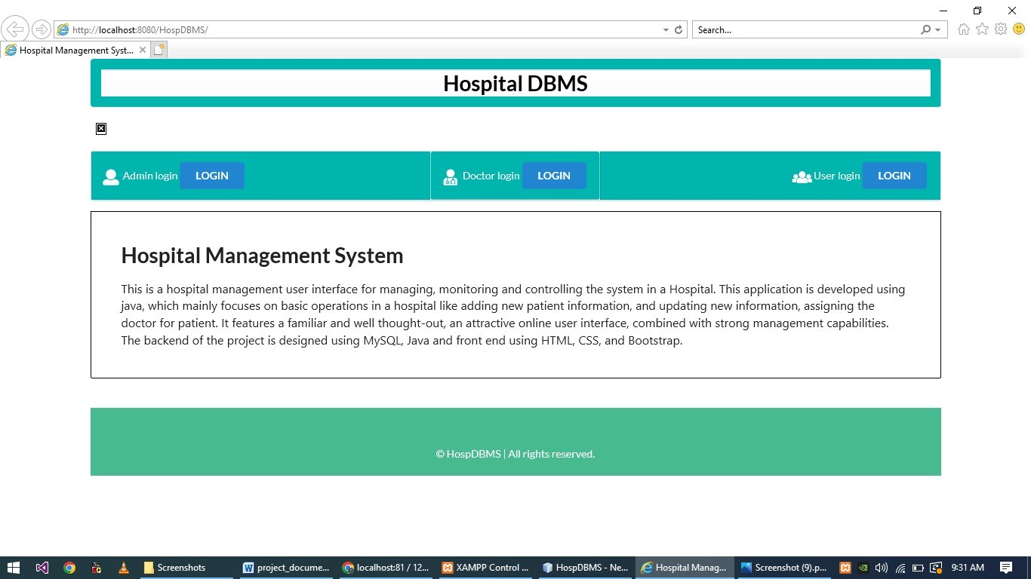

# Screen Shots

##### 2022-202

1. **Home Page**

##### 2)Admin Side

Hospital management **2021-2022**

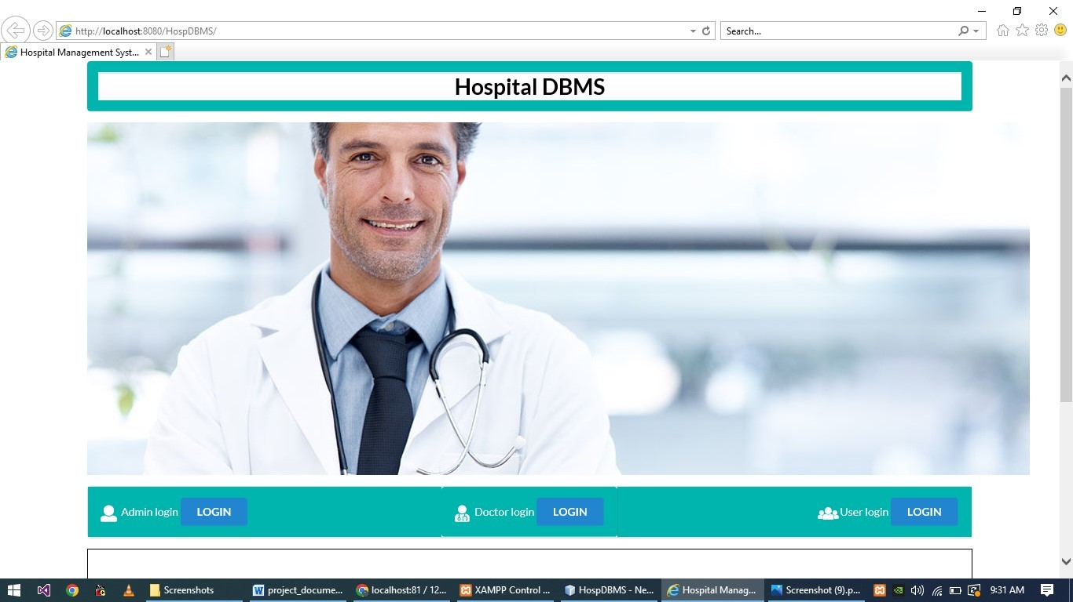

##### 3) Admin Login

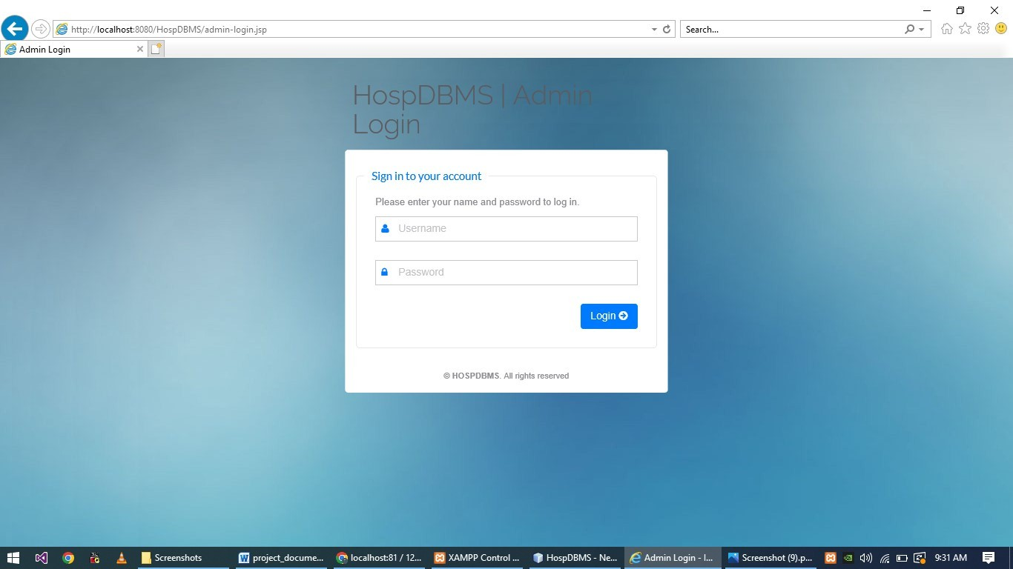

Hospital management

##### 4) DocDashboard

**2021-2022**

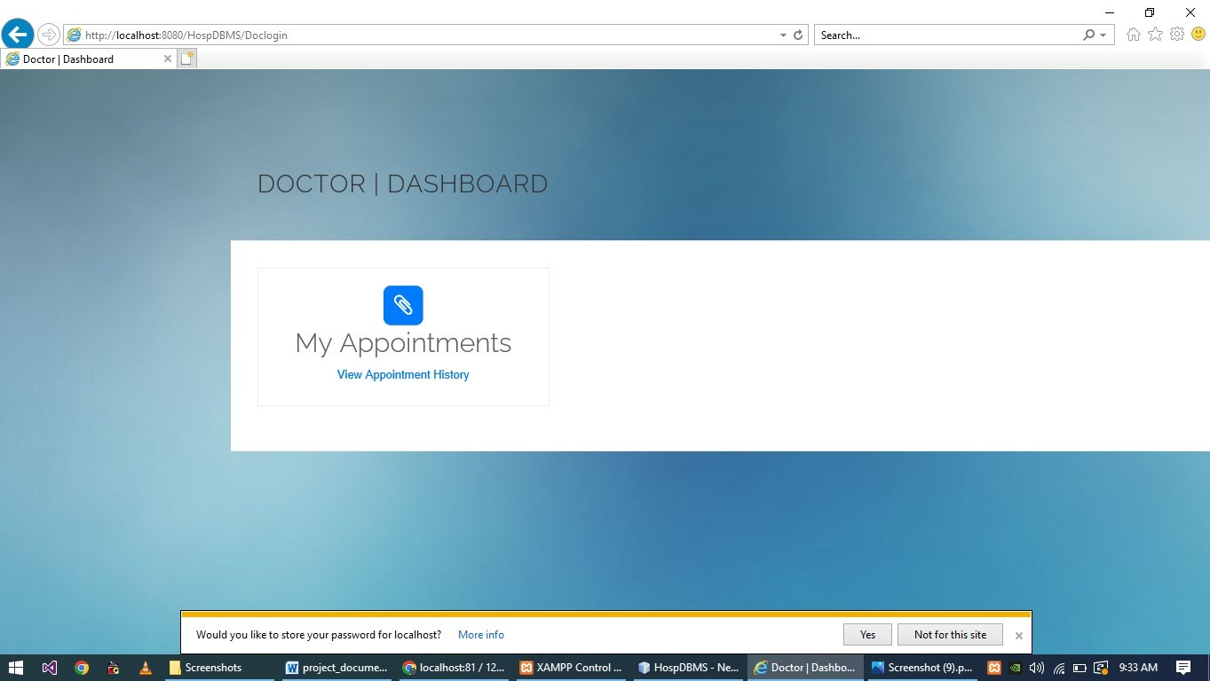

##### 5) Manage Appointment

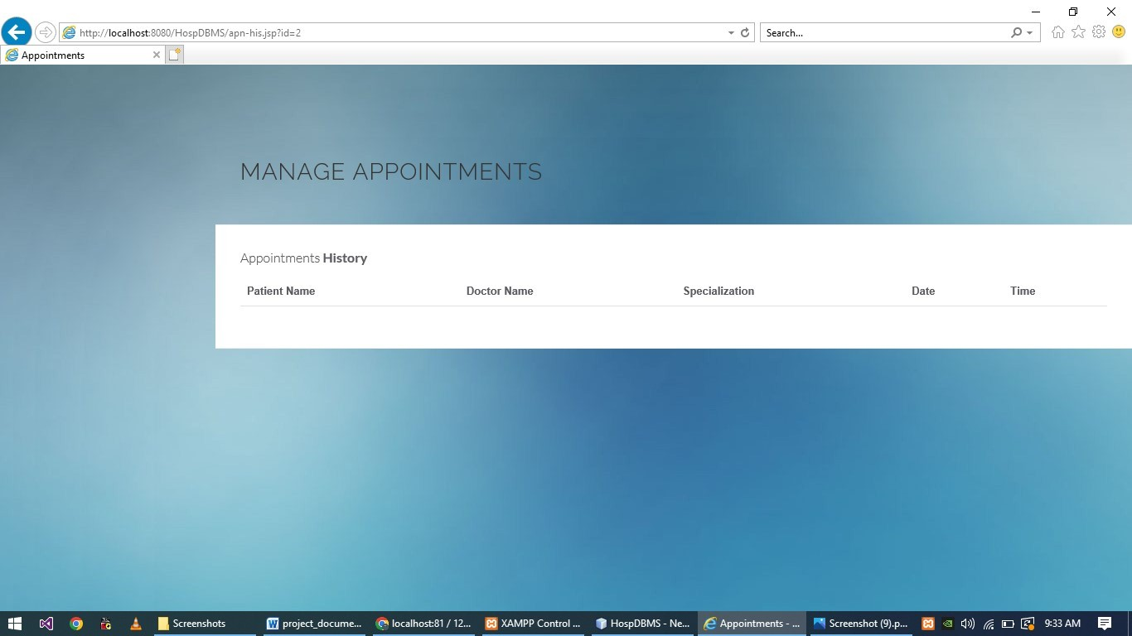

**6)User Dashboard**

Hospital management **2021-2022**

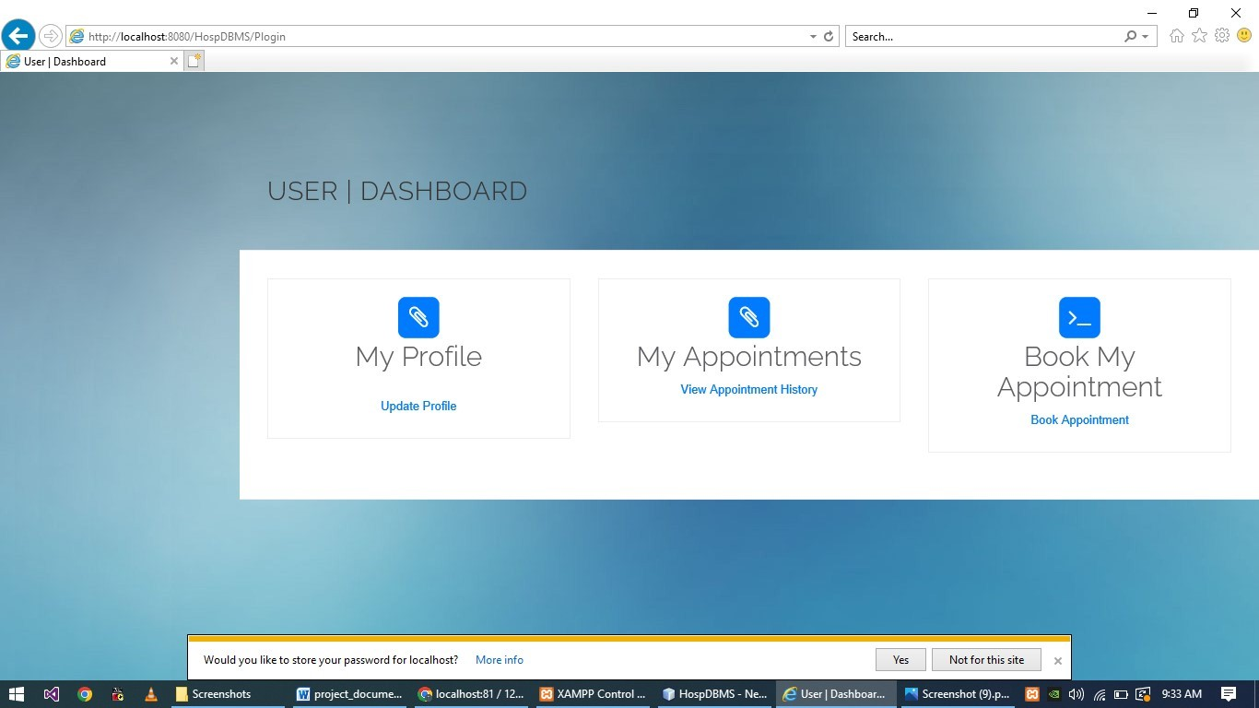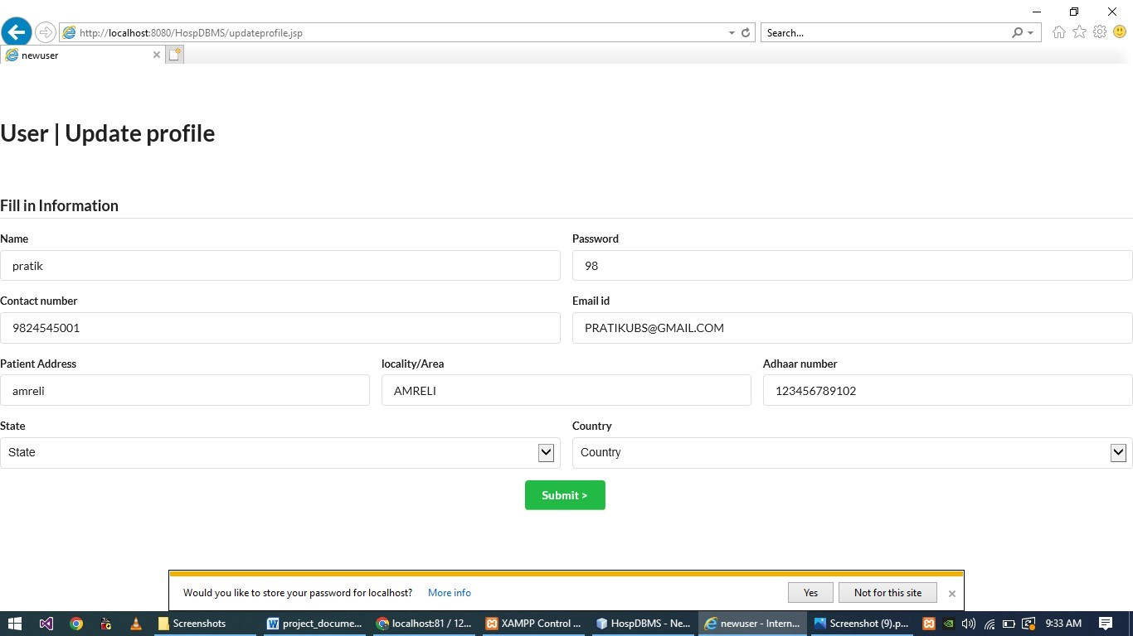

**7) Update Profile**

**8) Book Appointment**

Hospital management **2021-2022**

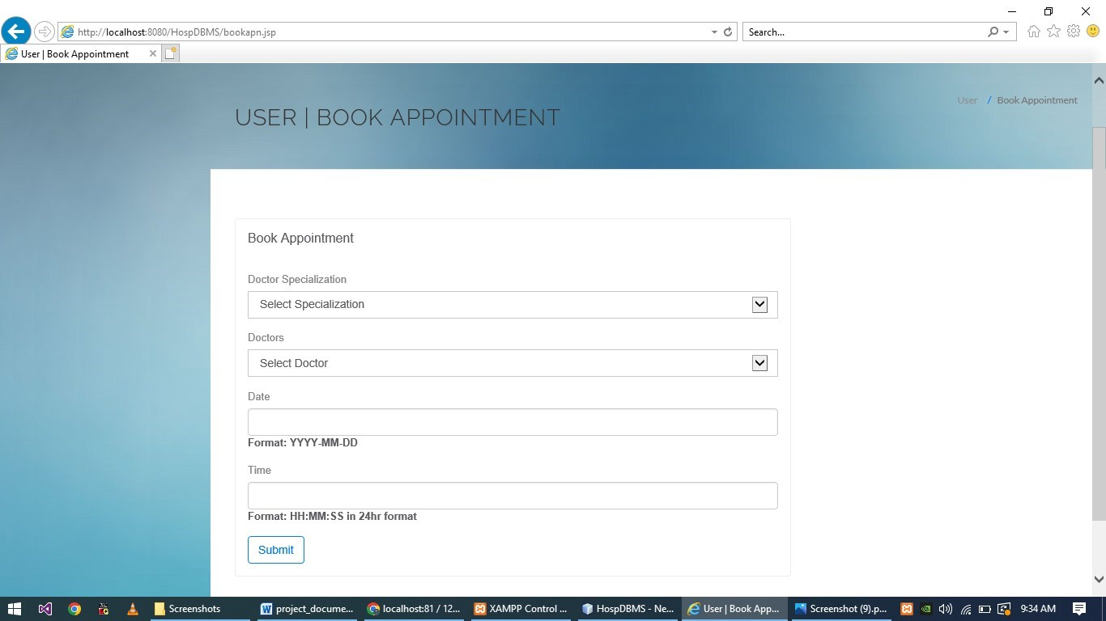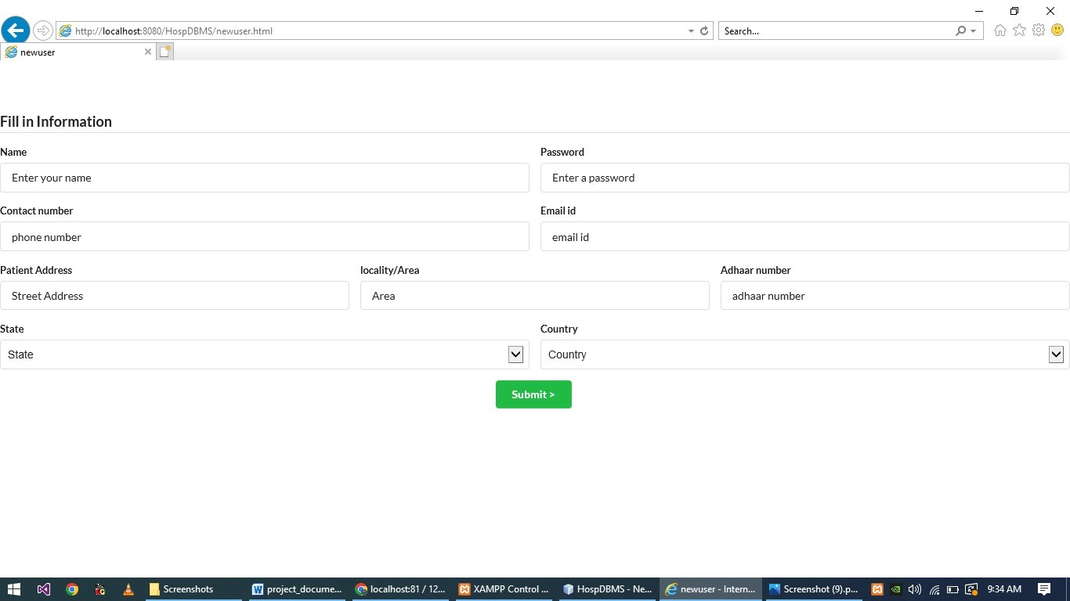

#### 9) Appointment Form

Hospital management

# Future Scope

##### 2022-2023

The future scope of this website can add more functionality like more security and privacy settings. Add PDF and Images to the users. Providing more themes to the users.

# Bibliography

1. www.javatpoint.com
2. Professional java (Wrox Publication)
3. [www.google.com](http://www.google.com/)